Site Visit Information for Teachers
Loans Box Booking Form
Museum of Lincolnshire Life

Please complete this form and return to lincolnshirelife_museum@lincolnshire.gov.uk
Your booking will be confirmed once we have received this form.
See reverse for Terms and Conditions and please sign to confirm your request.
Date of collection:  Saturday after 1pm |  | Date of return:  Saturday before 12 noon
Loans Box title: | Number of weeks  booked: |  | Total charge:  £16 per week
School/College: |  | School/College contact name:
School/College address:  Post code: |  | School/College email:  School/College telephone:  Contact telephone (incl. weekends):
How many people will use the Loans Box?
Students: Year group: Adults:

Person collecting Loans Box  Name (print):  Signature: |  | Person returning Loans Box  Name (print):  Signature:
Museum of Lincolnshire Life Visitor Experience Officer please complete
Payment collected (tick): Please attach a copy of the receipt to this form

Box returned (tick):  Contents check (tick): |  | Date returned:  Visitor Experience Officer
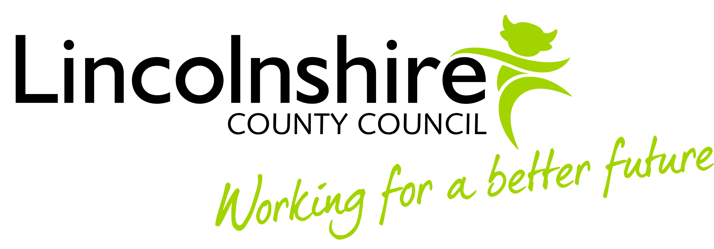

Terms and Conditions

Damaged or lost items

You must contact The Museum of Lincolnshire Life as soon as possible to report any loss or damage to the contents of the Loans Box. In some circumstances a payment may be necessary for the repair of any damaged items.

Picking up your Loans Box

Please collect Loans boxes from Reception at The Museum of Lincolnshire Life after 1pm on the first Saturday of your loan period. Loans Boxes can be collected on another later day during your booking period should you wish.

Returning your Loans Box

Loans Boxes must be returned before 1pm on the return date. You can return your loans box on an earlier day if you wish. This is very important as another school may be collecting your Loans Box on the day it is returned.

Payment

Loans Boxes are charged at £16 per week.
£ Please pay for your Loans Box when you collect it. You can pay with cash, cheque, or credit card and will receive a receipt.

Please note that we cannot invoice you for loans boxes.

Please sign to confirm that you have read the terms and conditions.

Signature

Date

If you have any questions please contact us at the address below.

Thank you,

The Investigate Learning team

Museum of Lincolnshire Life | Burton Road | Lincoln | LN1 3LY | 01522 782040 | Open daily 10am-4pm

